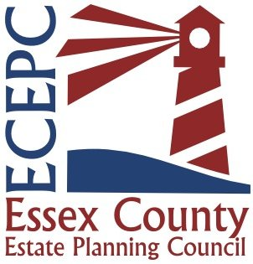

Newsletter

Volume 1 / Issue 3: August 2025

|  |
| --- |
| **New Member Welcomes**  **Events Calendar**  **Note from a Sponsor**  **Members’ Upcoming Events**  **Job Listings & Career Updates**  **Member Spotlight**  **Event Recaps**  **From the Board**  **Member Anniversaries** |
|  |
|  |

New Member Welcomes

Please join us in welcoming our newest member(s):

* Jennifer Reardon of The Octopus Life (www.theoctopuslife.com)

# ECEPC Events Calendar

* Tuesday, August 12, 5:30pm @ Michael’s Harborside, Newburyport – After-Hours Networking for Members (looking for a Sponsor!) ([RSVP Here](https://www.essexcountyepc.org/events/event/27786))
* RENEWAL SEASON BEGINS MID-AUGUST – KEEP AN EYE OUT FOR ANNUAL RENEWAL NOTICES!
* Wednesday, September 24th, 8:30am @ Red’s Kitchen, Peabody – Economic & Policy Updates for Estate Planning Professionals, sponsored by Blackstone ([RSVP Here](https://www.essexcountyepc.org/events/event/27787))
* October Date TBD – Business Succession Planning for Estate Planning Professionals
* November Event presently Date & Topic TBD
* December Holiday Get-Together Date & Location TBD

# Sponsor Notes

# We’re currently seeking sponsors! Interested in spotlighting your business or firm? Email the Board at [**ecepcouncil@gmail.com**](mailto:ecepcouncil@gmail.com)to learn more.

# Upcoming Member Events

From Members John Colucci & Joblin Younger:

](https://urldefense.com/v3/__https:/bit.ly/4lRfxiR__;!!Cz2fjcuE!l6Edfg8BTd6_hHHvdl_YOFjKqauZvfH0dnNX8MKN-VkoXjzinH0ZX0Nkc_LzrfGvvGRtWE1rk-IlCn8TQ6qCmbAvyPI$)

Hosting an event? Let us help promote it in the next newsletter.  
Submit details to [**ecepcouncil@gmail.com**](mailto:ecepcouncil@gmail.com).

# Job Listings & Career Updates

# Have a job opening or career news to share? We’re happy to include opportunities and celebrate milestones in our newsletter.

# Member Spotlight

# Would you like to be featured in an upcoming issue? Let us know after this first newsletter is live—we’d love to highlight your work!

# Event ReCaps

# This week we had a great time welcoming ~ 40 folks, more than half of them new prospective members, to our annual NAEPC-sponsored informational night @ Mission Boathouse – thank you to all who could make it and especially those who brought new faces!

# From the Board

# Very much looking forward to the 8/12 Event in Newburyport, hope to see you all there!

Contact Us

Kim Mahan, Administrator

[ecepcouncil@gmail.com](mailto:ecepcouncil@gmail.com)